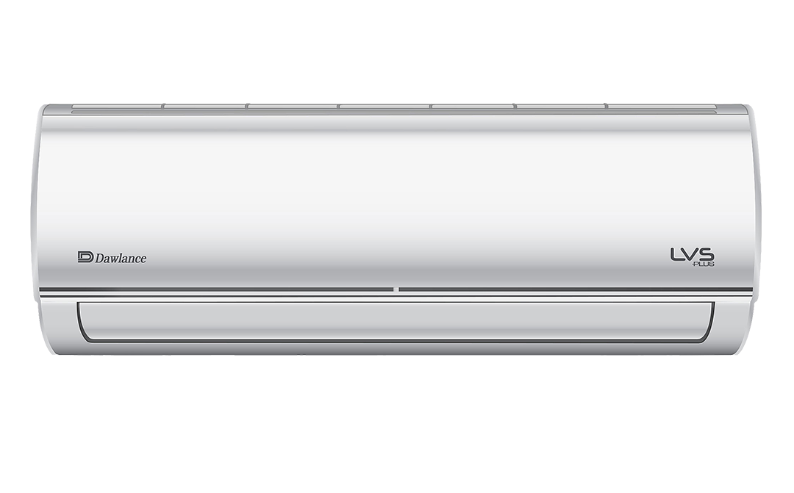

LVS PLUS 30

LVS Series We Have Got You Completely Covered.

**Rs:73,500.00**